**01 – Current Density & Charge Conservation**

**Topics:** Current density, conservation of charge (continuity equation).

**Summary:** Students first consider a cylindrically symmetric conductor having three regions of different cross-sectional area. The task here is to rank order the three regions in terms of several physical quantities in those regions: conductivity, total current, current density and electric field. The remaining tasks connect the flux of the current density through a closed surface to the rate of change of the charge enclosed within the volume.

**Written by:** Michael Dubson, Charles Baily and Steven Pollock.

**Contact:** Steven.Pollock@Colorado.EDU

**Comments:** Students should be able to complete these tasks within 15 minutes. The first part has been used in various forms, as a class activity or in the form of a series of concept tests; it is assumed that students have already had an introduction to the microscopic version of Ohm’s law. The ordering of the quantities to be ranked in Part I is chosen to build off an intuition for total current being conserved, but some students may need to be cued to consider this – they may have a better intuition for one of the other quantities, so the ordering is not essential. The second part goes stepwise through the derivation of the continuity equation in integral form. Instructors should be sure that students recognize that the outward flow of current corresponds to positive flux, and that  is a positive quantity. A challenge question appears at the end for students who are quick to finish, which has them convert the integral form of the continuity equation to its differential form. We’ve noticed that the greatest difficulty for students comes in justifying dropping the integration symbols in the final step, which can only be done if the integral equation holds for an arbitrary volume. Even though students may agree that the equality of two integrals doesn’t necessarily mean the integrands are equal, they may still make this mistake without thinking too much about it.

**A.** A copper cylinder is machined to have the following shape. The ends are connected to a battery so that a current flows through the copper.

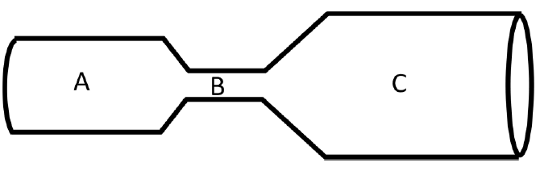

For each of the following quantities, rank order their magnitudes in each of the three regions (e.g., A = C > B, etc…).

**Total current:**

**Current density:**

**Conductivity:**

**Electric field:**

:::::Screen shot 2012-05-30 at 11.33.08 AM.png**B.** A volume V contains a net charge . What is the relationship between  and the charge density ?

What is the relationship between the rate of change of  and the net current flowing *from the interior to the exterior* of the volume (the total charge *leaving* the volume per unit time)? Make sure you have your signs correct.

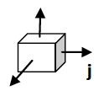

Consider the *current density* , which is a function of position. What is the total charge leaving the volume per unit time, in terms of a flux integral of ?



Explain how these results can be combined to get an integral equation that guarantees *charge is conserved*.

**Challenge Question:** Use the divergence theorem to convert the integral form of this equation to its differential form.